Journal Article Title: Tools for AWIA Compliance
NAME OF AUTHOR: Charlene Kormondy

AGENCY: U.S. Environmental Protection Agency, Office of Water, Water Security Division

ADDRESS: 1200 Pennsylvania Ave, NW, Washington, D.C. 20460

PHONE: (202) 564-3807

E-MAIL: kormondy.charlene@epa.gov

Water utilities today face unprecedented threats to the security and resilience of their systems. In Virginia, drinking water utilities may be susceptible to a wide array of extreme weather events, such as floods, droughts, and winter storms that can damage treatment and distribution systems, disrupt power supplies, and potentially contaminate source waters. When disasters do occur, rural water systems serve as a critical lifeline for water systems, public health and the community at large. While responding to natural disasters can be challenging, you can take steps now to prepare your utility and community for future incidents.

America’s Water Infrastructure Act – Section 2013

One of the first steps to prepare for disasters is to conduct a detailed assessment of your risks. The America’s Water Infrastructure Act (AWIA) Section 2013 requires Community (drinking) Water Systems (CWSs) serving more than 3,300 people to develop or update a Risk and Resilience Assessment (RRA) and Emergency Response Plan (ERP). The law outlines what components must be included in the RRAs and ERPs and establishes deadlines by which water systems must send a certification of completion to the United States Environmental Protection Agency (EPA).

The certification deadlines are based on system population size reflected in the Safe Drinking Water Information System as of October 23, 2018, the date when the AWIA was enacted. Compliance deadlines depend on the system size:
System Size | Risk and Resilience Assessment | Emergency Response Plan
If serving over 100,000 people | March 31, 2020 | September 30, 2020
If serving 50,000 to 99,999 people | December 31, 2020 | June 30, 2021
If serving 3,301 to 49,999 people | June 30, 2021 | December 30, 2021

Within six months of certifying completion of the RRA, water systems must also certify completion of the ERP. The AWIA requires systems to consider factors such as monitoring practices, financial systems, chemical storage, and operations and maintenance in their RRAs. For the ERP, the AWIA requires utilities to include items such as strategies and resources to improve resilience and procedures to lessen the impact of malevolent acts or natural hazards. See the following webpage for more information and details about the AWIA - https://www.epa.gov/waterresilience/americas-water-infrastructure-act-risk-assessments-and-emergency-response-plans

AWIA Compliance Resources

If CWSs need help meeting these requirements, EPA has several tools available to help systems develop their RRAs and ERPs. EPA does not require water systems to use these or any designated standards, methods or tools to conduct the RRAs or to prepare the ERPs. Rather, these tools are provided as optional support during the process:
- Baseline Information on Malevolent Acts for Community Water Systems: The information in this document can help systems identify and assess the likelihood of malevolent acts occurring at their water system as part of their RRA.
- Vulnerability Self-Assessment Tool (VSAT 2.0): VSAT 2.0 is a user-friendly tool that can help drinking water utilities of all sizes conduct an RRA.
- Small System Risk and Resilience Assessment Checklist: This guidance is intended for small CWSs serving greater than 3,300 but less than 50,000 people to comply with the AWIA requirements for RRAs.
- Emergency Response Plan Guidance: This template and instructions will assist water utilities with developing or updating an ERP in accordance with the AWIA.
- How to Certify Your Risk and Resilience Assessment or Emergency Response Plan: This webpage explains the three options available to CWSs for submitting certification statements and includes a training video on the electronic certification option.
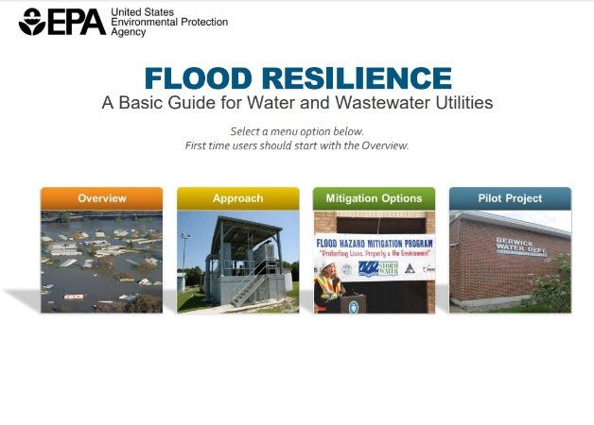
Other Resources
After completing an RRA and ERP, utilities can further explore how to lower risks and increase resiliency using EPA tools and resources. The Flood Resilience Guide provides practical solutions to help drinking water utilities respond to and recover from floods. The guide presents real-world examples of flood scenarios that Virginia water utilities might face and includes information on staffing, emergency response plans, funding, water supply and demand management, communications, and partnerships.

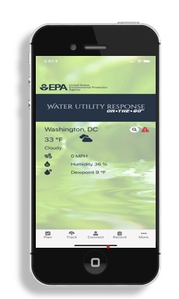
The Water Utility Response On-The-Go (Response OTG) Application is an interactive tool allowing real time access to response resources to track severe weather, contact response partners, identify key response actions, and document damages.

Learn more about these and many other water utility resilience resources at: https://www.epa.gov/waterutilityresponse.

EPA provides regular updates on water security and resilience resources. To learn more, visit www.epa.gov/waterresilience or join the What’s Going On newsletter email list by contacting WSD-outreach@epa.gov. Use these free water resilience resources as you continue working toward providing safe and reliable services to customers during emergencies.

